Chapter 9, Problem 57.

At ω = 1 rad/s, obtain the input admittance of the circuit in Fig. 9.64.

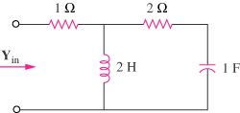

Figure 9.64
For Prob. 9.57.

